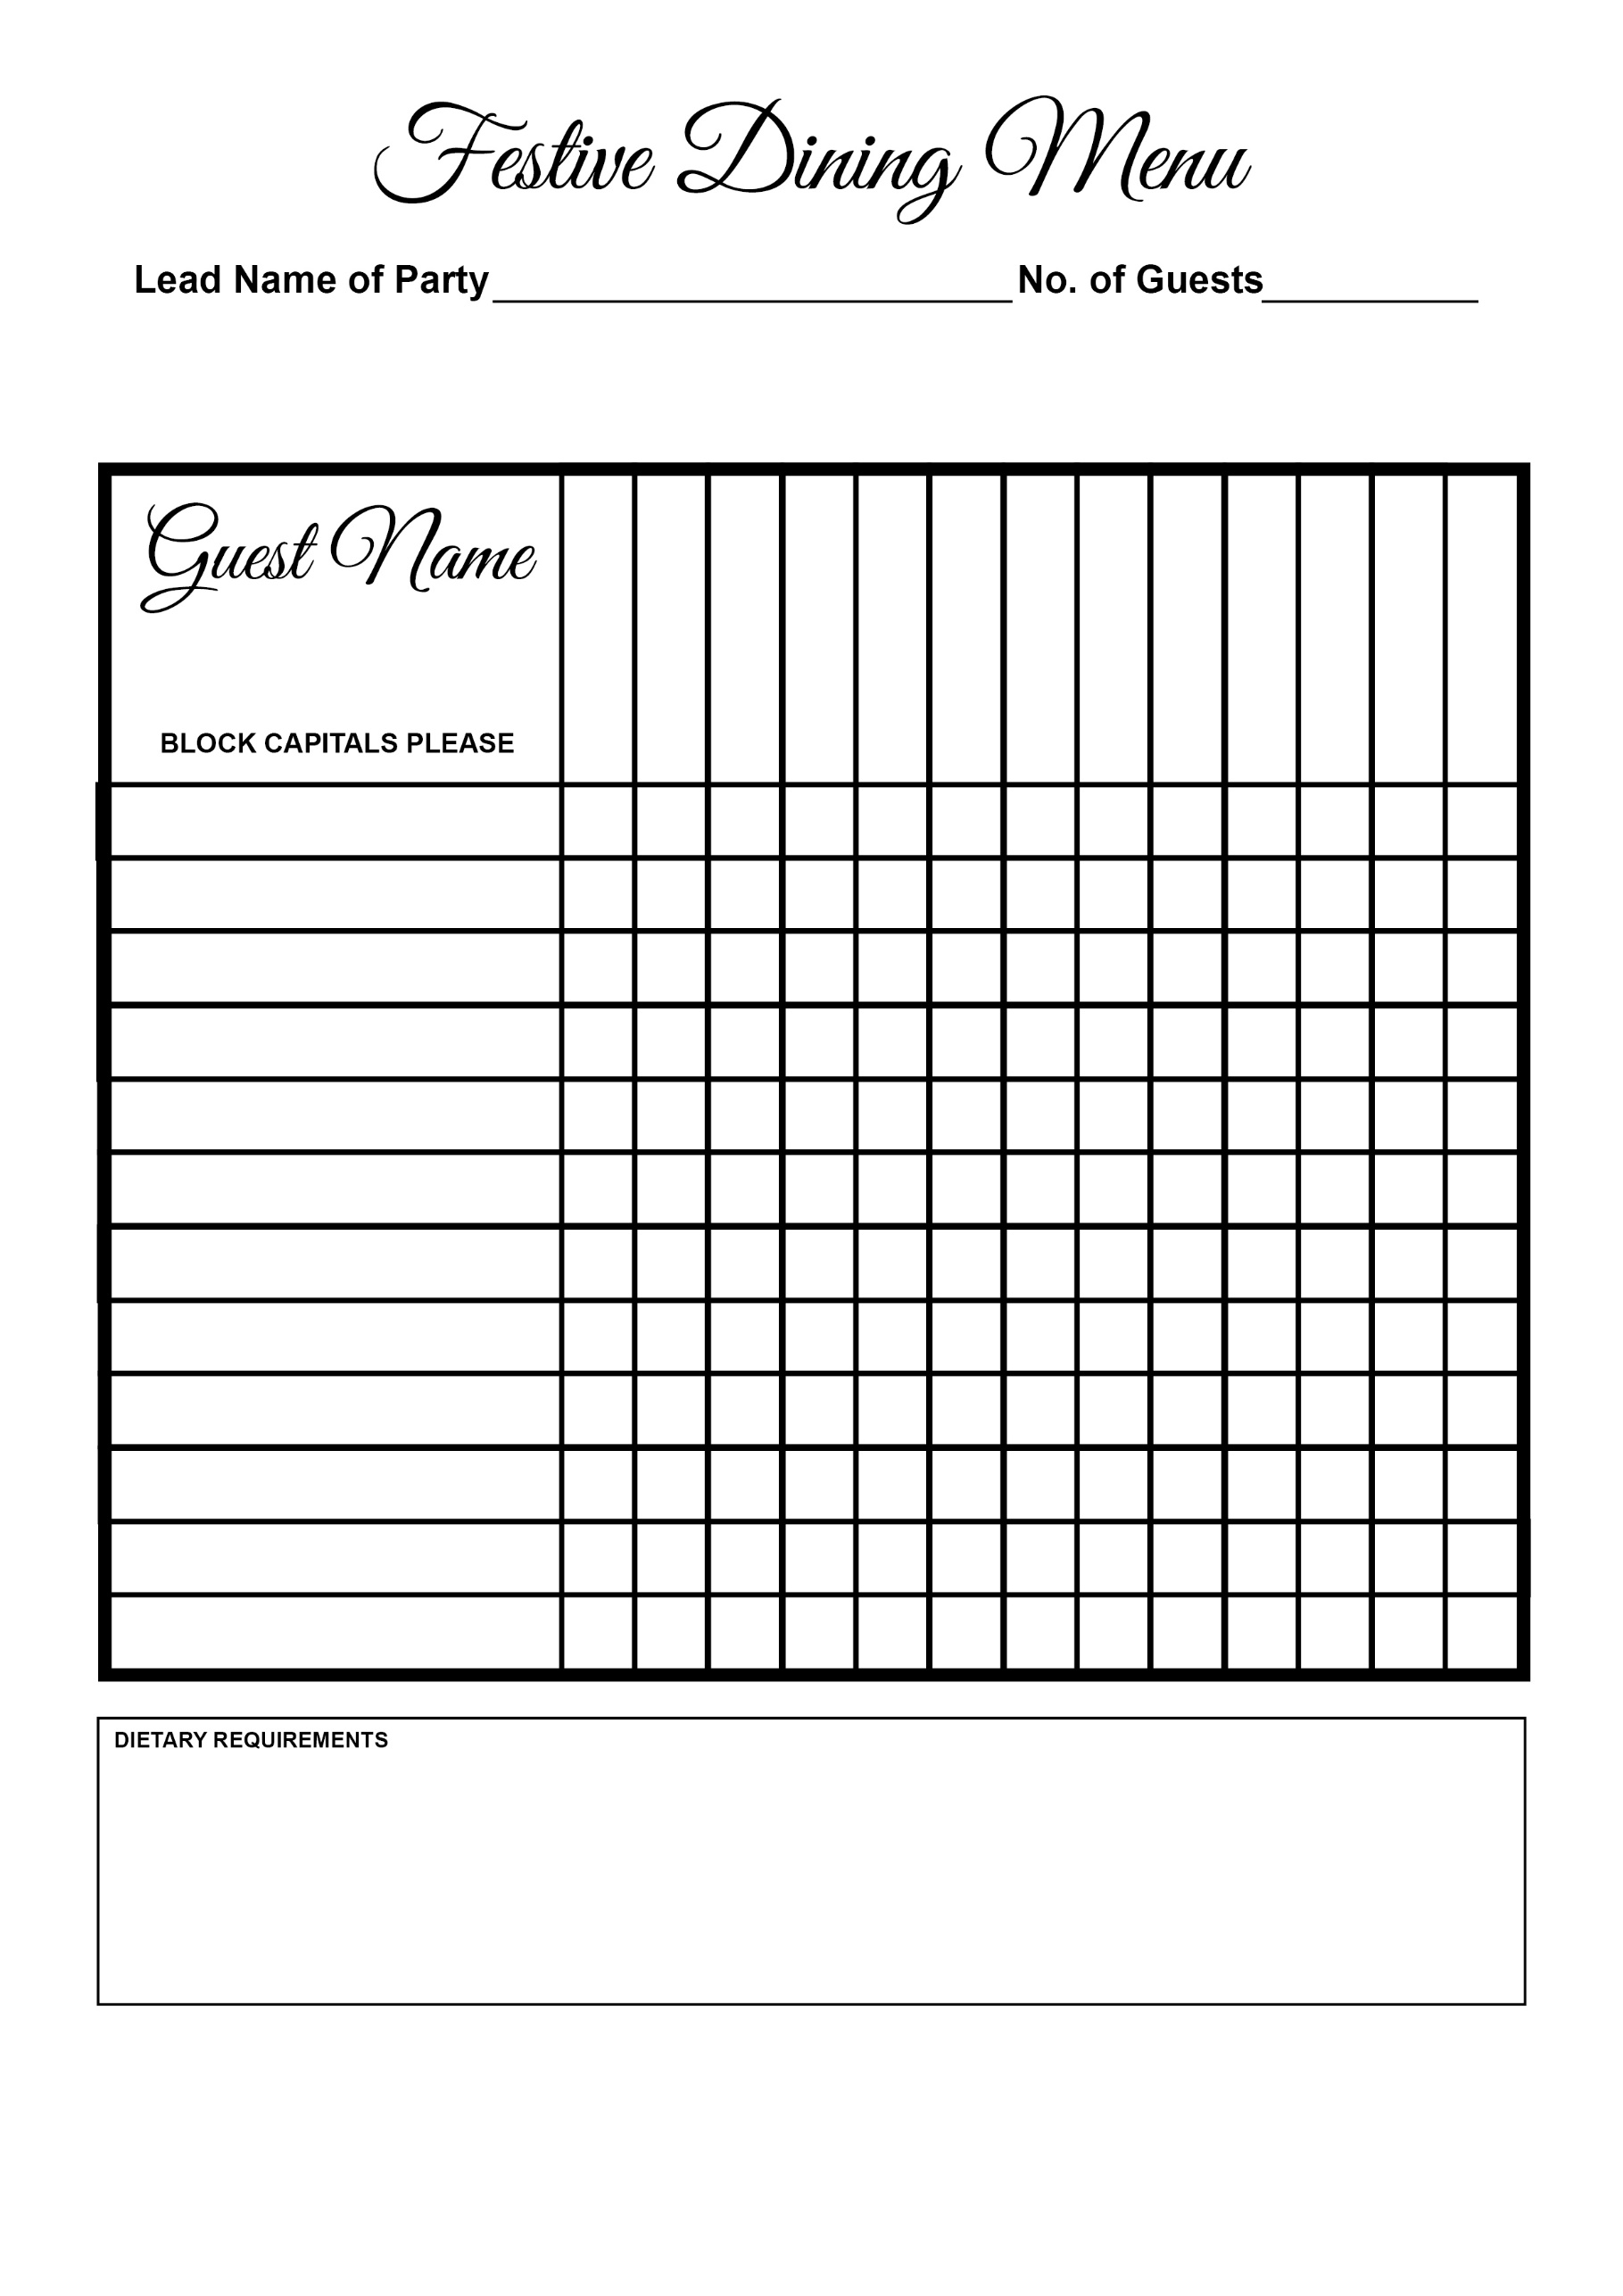

Christmas Pudding

Ham Hock Terrine

Sticky Toffee Pudding

Brulee

Pan Fried Hake

Wellington

Turkey

Salmon

Soup